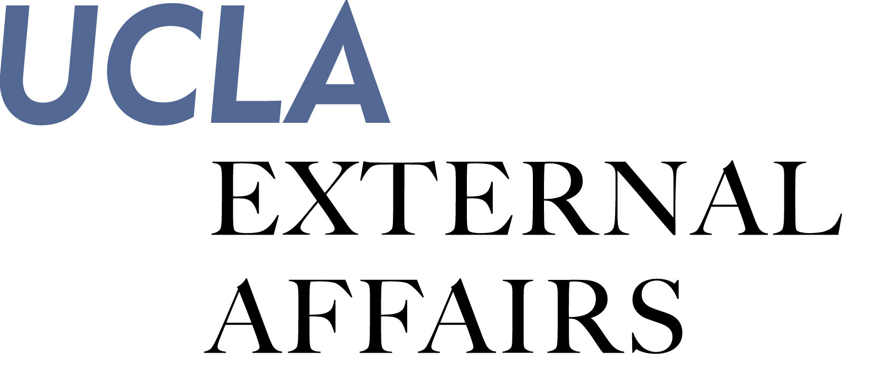

FORM 1A
July/August/September
Supervisor & Employee Complete

Staff Performance Evaluation & Development Plan

Employee Name: |  | Payroll Title:
Unit/Division: |  | Supervisor:

Review Period From: |  | To: |  |  | Probationary Period Review

Key Result Areas / Performance Objectives:
Define up to five key result areas and corresponding measurable performance objectives with your employee.
Step 1: Supervisor defines key result areas & performance objectives based on the job description and position responsibilities at the beginning of the evaluation period.
Step 2: Supervisor and employee discuss and finalize the key result areas & performance objectives.
Step 3: Supervisor documents the key result areas & performance objectives and provides a copy to the employee.
Step 4: Supervisor reviews key result areas & performance objectives periodically.

Key result areas/performance objectives:
Established mm/dd/yy |  | Reviewed mm/dd/yy |  | Reviewed mm/dd/yy

Key Result #
Performance Objectives
A: |  |  |  | Superior  Meets Expectations  Needs Improvement  Unsatisfactory
B: |  |  |  | Superior  Meets Expectations  Needs Improvement  Unsatisfactory
C: |  |  |  | Superior  Meets Expectations  Needs Improvement  Unsatisfactory
D: |  |  |  | Superior  Meets Expectations  Needs Improvement  Unsatisfactory
Comments:

Key Result #
Performance Objectives
A: |  |  |  | Superior  Meets Expectations  Needs Improvement  Unsatisfactory
B: |  |  |  | Superior  Meets Expectations  Needs Improvement  Unsatisfactory
C: |  |  |  | Superior  Meets Expectations  Needs Improvement  Unsatisfactory
D: |  |  |  | Superior  Meets Expectations  Needs Improvement  Unsatisfactory
Comments:

Key Result #
Performance Objectives
A: |  |  |  | Superior  Meets Expectations  Needs Improvement  Unsatisfactory
B: |  |  |  | Superior  Meets Expectations  Needs Improvement  Unsatisfactory
C: |  |  |  | Superior  Meets Expectations  Needs Improvement  Unsatisfactory
D: |  |  |  | Superior  Meets Expectations  Needs Improvement  Unsatisfactory
Comments:

Key Result #
Performance Objectives
A: |  |  |  | Superior  Meets Expectations  Needs Improvement  Unsatisfactory
B: |  |  |  | Superior  Meets Expectations  Needs Improvement  Unsatisfactory
C: |  |  |  | Superior  Meets Expectations  Needs Improvement  Unsatisfactory
D: |  |  |  | Superior  Meets Expectations  Needs Improvement  Unsatisfactory
Comments:

Key Result #
Performance Objectives
A: |  |  |  | Superior  Meets Expectations  Needs Improvement  Unsatisfactory
B: |  |  |  | Superior  Meets Expectations  Needs Improvement  Unsatisfactory
C: |  |  |  | Superior  Meets Expectations  Needs Improvement  Unsatisfactory
D: |  |  |  | Superior  Meets Expectations  Needs Improvement  Unsatisfactory
Comments:

FORM 1B
July/August/September
Supervisor Completes

Skills and Abilities – All Staff

1. Supervisor designates S&As as “critical” or “important”
2. Supervisor rates the employee’s S&As on an annual basis

 | Important
 | Critical
 | Job Knowledge | Understands job duties and responsibilities. Has necessary job skills and knowledge. Promotes External Affairs mission and values. | Superior  Meets Expectations  Needs Improvement  Unsatisfactory
Comments:
 | Problem Solving/ Decision Making | Anticipates, prevents and solves problems. Defines and analyzes problems and identifies root causes. Makes decisions that are appropriate and consistent with any given situation. | Superior  Meets Expectations  Needs Improvement  Unsatisfactory
Comments:
 | Creativity/  Innovation | Implements innovative programs and improved work methods. Generates alternative/original solutions and new approaches. | Superior  Meets Expectations  Needs Improvement  Unsatisfactory
Comments:
 | Communication/ Interpersonal Skills | Presents ideas and information effectively. Demonstrates clear, concise, and appropriate written and oral communication skills. Exchanges information and opinions constructively. Demonstrates political acumen. | Superior  Meets Expectations  Needs Improvement  Unsatisfactory
Comments:
 | Planning/  Goal-Setting | Sets appropriate goals, aligns priorities, and meets deadlines. Balances short- and long-term goals. Seeks opportunities to support business goals and “big picture”. Thinks and acts strategically. | Superior  Meets Expectations  Needs Improvement  Unsatisfactory
Comments:
 | Collaboration/ Teamwork | Works with others in a coordinated effort to achieve the best possible outcomes. Shares resources and expertise toward common goals. | Superior  Meets Expectations  Needs Improvement  Unsatisfactory
Comments:
 | Customer Service | Treats customers with respect, accountability, and open communication. Delivers a quality product promptly and consistently according to commitments. Represents the department professionally. Understands and demonstrates External Affairs service values with each interaction with internal and external constituents. | Superior  Meets Expectations  Needs Improvement  Unsatisfactory
Comments:
 | Flexibility/  Adaptability | Adapts to changes within the organization. Performs a variety of tasks simultaneously in response to changing priorities and shifting workloads. Looks for and takes advantage of opportunities for improvement. | Superior  Meets Expectations  Needs Improvement  Unsatisfactory
Comments:
 | Technology | Demonstrates ability to use information technology in completing assigned job tasks. | Superior  Meets Expectations  Needs Improvement  Unsatisfactory
Comments:
 | Resource Management | Makes decisions that maximize resources, increases productivity, and results in cost effectiveness. | Superior  Meets Expectations  Needs Improvement  Unsatisfactory
Comments:
Superior
Meets Expectations
Needs Improvement
Unsatisfactory
Comments:
Superior
Meets Expectations
Needs Improvement
Unsatisfactory
Comments:

CONTINUED ON NEXT PAGE
Skills and Abilities – Supervisors/Managers (only)

 | Important
 | Critical
 | Managing Performance | Motivates staff, provides praise and constructive feedback, and counsels poor performance. Delegates responsibilities, and negotiates and establishes priorities. | Superior  Meets Expectations  Needs Improvement  Unsatisfactory
Comments:
 | Recruiting and Developing Talent | Recruits a diverse workforce, develops employees, delivers effective performance evaluations and mentors staff for success and retention. | Superior  Meets Expectations  Needs Improvement  Unsatisfactory
Comments:
 | Organizational Cooperation | Encourages staff to work across departments to produce results. Achieves results with same-level supervisors across the organization. | Superior  Meets Expectations  Needs Improvement  Unsatisfactory
Comments:
 | Decision Making and Judgment | Analyzes problems or procedures, evaluates alternatives, and selects best course of action. Uses logic and common sense in decision making. | Superior  Meets Expectations  Needs Improvement  Unsatisfactory
Comments:
Superior
Meets Expectations
Needs Improvement
Unsatisfactory
Comments:

FORM 1C
July/August/September
Supervisor & Employee Complete

Overall Performance Rating & COMMENTS

Your divisional AVC must review this form before it is presented to the employee.

Overall Performance Rating: | Superior  Meets Expectations  Needs Improvement  Unsatisfactory

Supervisor Comments

Employee Comments (optional)

I have received and reviewed this evaluation of my performance. My signature indicates neither agreement
nor disagreement with the content of the evaluation.

Employee Signature: Date:

Supervisor Signature: Date:

Senior Mgr Signature: Date:

AVC Signature: Date:
Professional Development Plan

FORM 2
July/August/September
Supervisor & Employee Complete
Professional/Career Development Goals

Employee identifies professional interests, goals, plans, or strategies to communicate during performance evaluation review meeting. This exercise will support the development-planning process.

Development Plan

Supervisor and employee discuss opportunities to enhance performance and professional development and create development plan relative to performance evaluation discussion.

Employee Signature Date:
Supervisor Signature Date:
Senior Mgr Signature Date:
AVC Signature Date:

